Complex Engineering Problem Intermediate Design and Progress Assessment (EE-313)
Project Title:
Design and Implementation of a Microcontroller-Based Speed Control System for a DC Motor Using a Three-Phase AC Supply.
Project Team
S.No. | Name | Roll No. | Section
1 | Muhammad Taha* | EE-23319 | D
2 | Ali Nasir | EE-23328 | D

Summary of Progress:
This project uses a three-phase full-wave rectifier with a buck converter to control a DC motor. The three-phase rectifier converts AC power into DC by using six diodes arranged in a bridge configuration. This produces a smooth DC output with less ripple compared to a single-phase system.
The rectified DC is then supplied to a buck converter, which steps down and regulates the voltage. By adjusting the PWM (Pulse Width Modulation) signal, the converter controls the output voltage and current, allowing precise speed control of the DC motor.
This setup efficiently converts three-phase AC power into a stable and controllable DC supply for motor operation. It offers high efficiency, reduced ripple, and smooth motor performance, making it suitable for applications such as industrial drives, electric vehicles, and automation systems.
The circuit diagram designed in Multisim is shown below, illustrating the complete setup of the three-phase full-wave rectifier with a buck converter controlling the DC motor.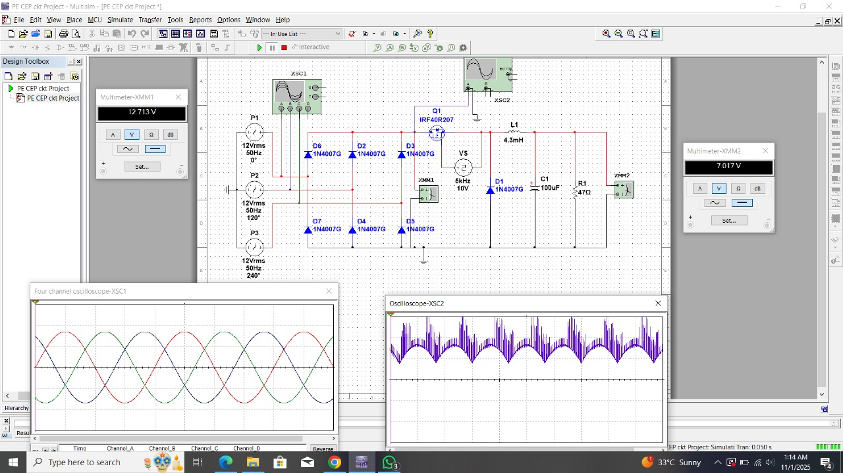
The following image shows the hardware setup of the three-phase full-wave rectifier with a buck converter controlling the DC motor.
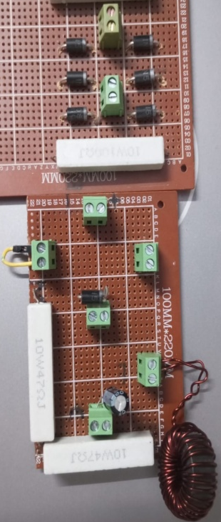
Task Completed
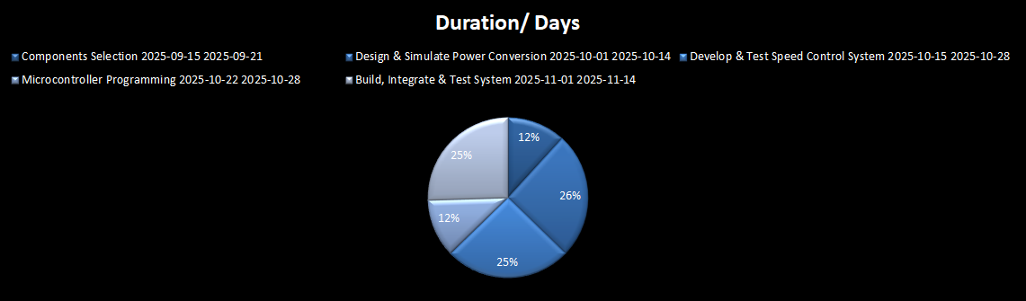
Summarized:
The Gantt Chart above represents the planned and actual timeline for circuit design tasks. The table summarizes reasons for any observed delays and adjustments during execution.
Circuit Design
Three Phase AC to DC conversion
The three-phase AC supply is converted into DC using a three-phase full-wave bridge rectifier. This rectifier uses six diodes arranged in a bridge configuration. At any moment, two diodes conduct, one from the positive side and one from the negative, allowing current to flow in a single direction through the load. Each phase conducts for 120° of the cycle, producing a pulsating DC output with significantly less ripple compared to a single-phase rectifier. This smoother DC output is suitable for powering and controlling DC devices.
The following image shows the simulation of the three-phase rectifier circuit, illustrating how the three-phase AC supply is converted into DC using a full-wave bridge configuration.
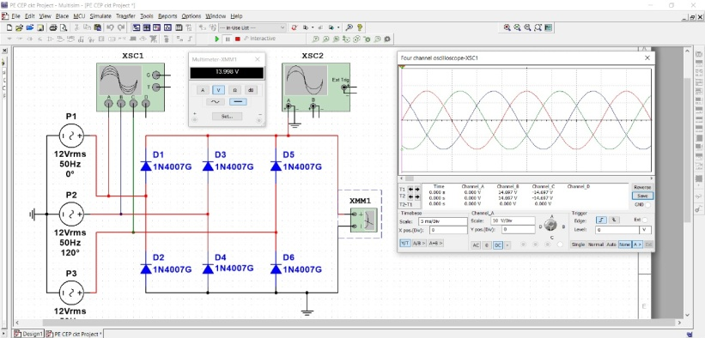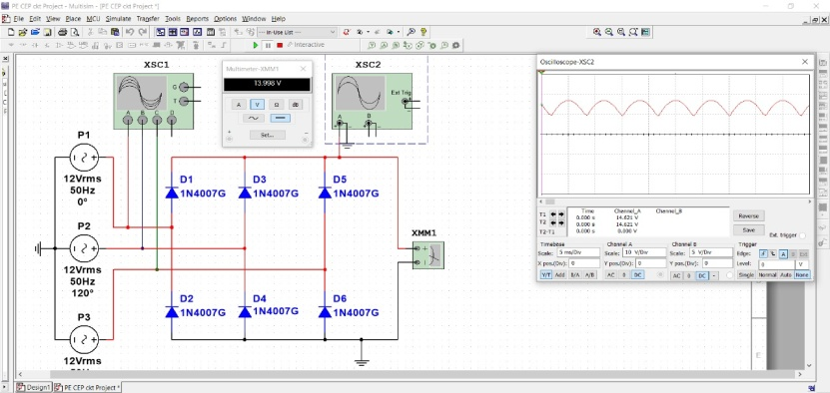
The following image shows the hardware setup and testing of the three-phase rectifier circuit, demonstrating the practical implementation of AC to DC conversion.
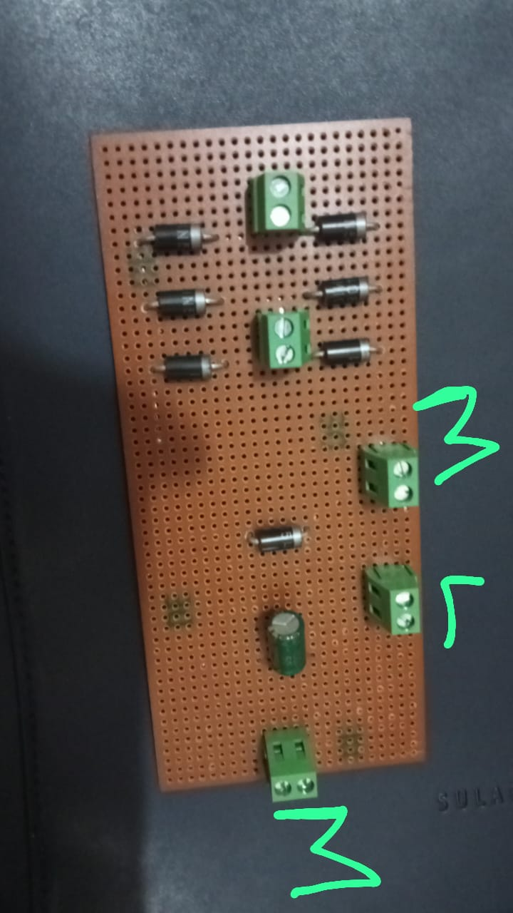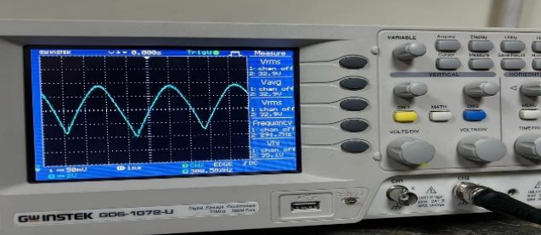
Constant DC to variable DC conversion
The constant DC voltage obtained from the rectifier is converted into a variable DC voltage using a buck converter (DC-DC converter). The buck converter operates by rapidly switching a transistor (MOSFET) on and off, controlling the average voltage delivered to the load. By adjusting the duty cycle of the PWM (Pulse Width Modulation) signal, the output voltage can be increased or decreased as needed. An inductor and capacitor are used to smooth the output, reducing voltage ripple. This process allows efficient control of the DC motor speed or any other DC load requiring variable voltage.
The following image shows the simulation of the buck regulator operating at different duty cycles, demonstrating how the output voltage varies with changes in the PWM control signal.
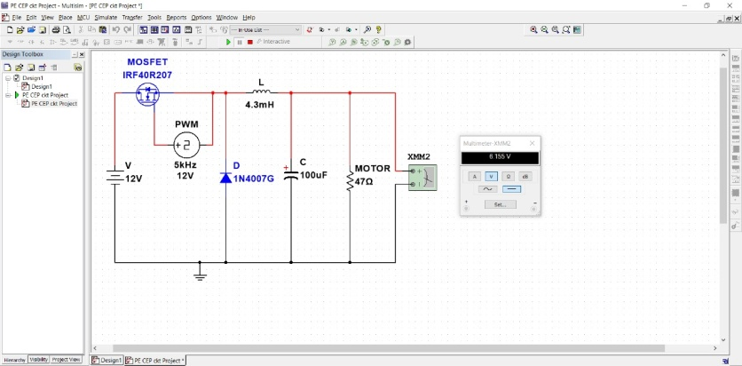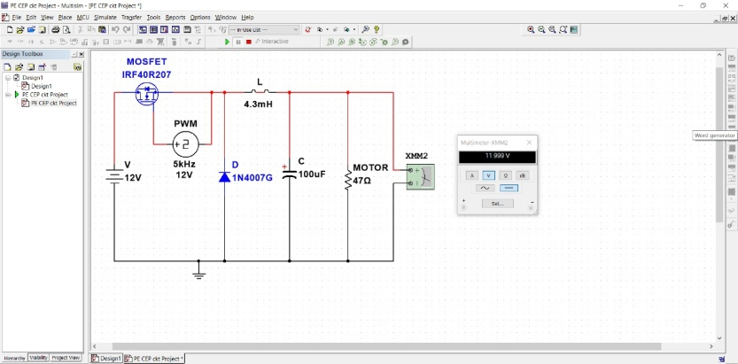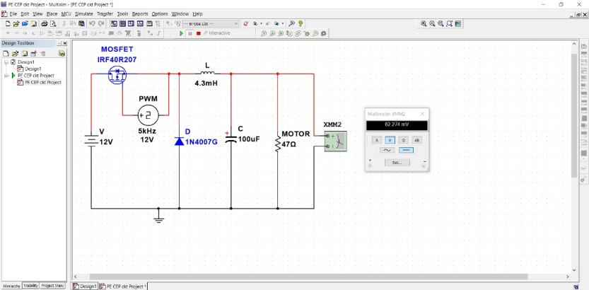
$∴$ 01% duty cycle approximately 1mV output

$∴$ 100% duty cycle approximately 12V output

$∴$ 50% duty cycle approximately 6V output

The following image shows the hardware circuit of the buck regulator, illustrating its practical implementation for converting constant DC into variable DC.
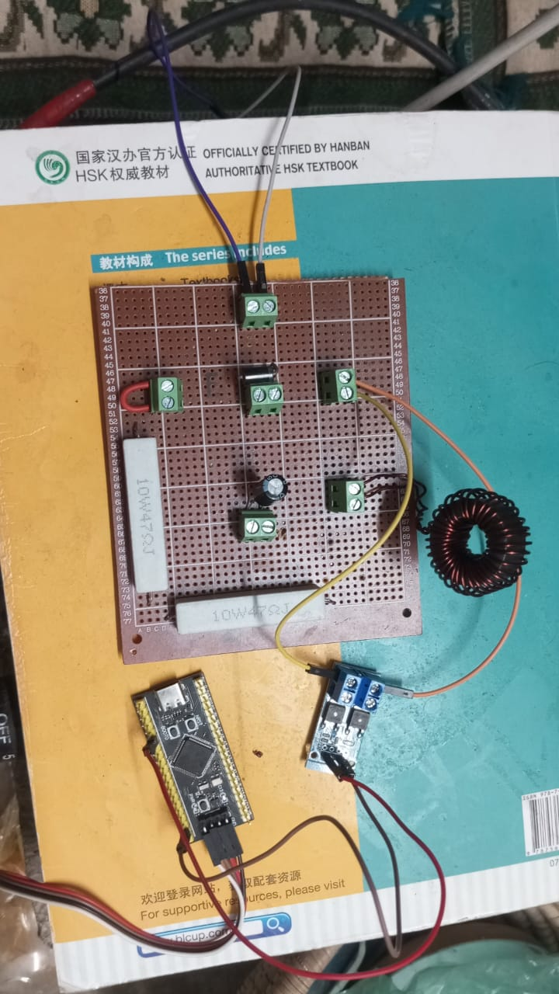
Time Scheduling
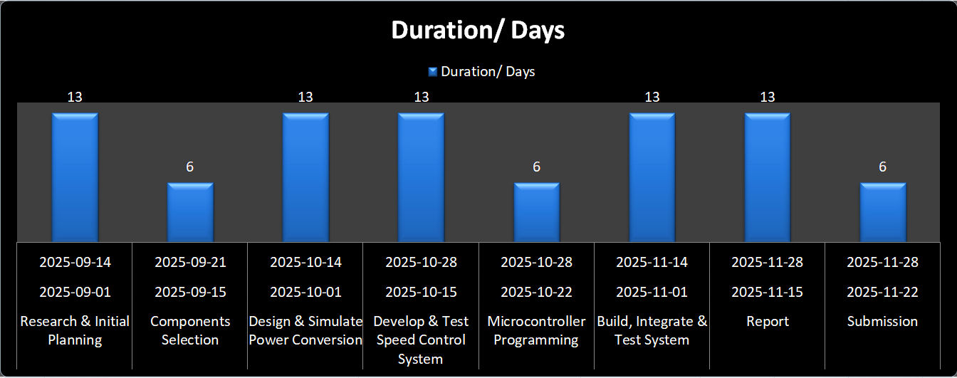
Risk Assessment and Mitigation
Risk Mitigation
During the circuit design phase, several high-priority risks were identified and addressed using appropriate mitigation strategies. The main risks included component failure, simulation errors, PWM signal instability, and hardware connection faults.
To manage these, risk reduction strategies were applied by thoroughly testing each component in simulation before hardware implementation. Risk avoidance was practiced by verifying circuit parameters and ratings to prevent overcurrent or voltage damage. Risk monitoring and control were used throughout the process by continuously checking output waveforms and motor responses during testing. In case of hardware faults, risk transfer was managed by consulting technical supervisors and referring to verified datasheets and design standards.
Overall, these mitigation strategies helped ensure reliable circuit operation, reduced chances of hardware failure, and maintained consistent performance during both simulation and testing phases.
References
[1] N. Mohan, T. M. Undeland, and W. P. Robbins, Power Electronics: Converters, Applications, and Design. Hoboken, NJ, USA: John Wiley & Sons, 2003.
[2] M. H. Rashid, Power Electronics: Circuits, Devices, and Applications, 4th ed. Upper Saddle River, NJ, USA: Pearson, 2013.
[3] “Speed Control of DC Motors,” University of Diyala, [Online]. Available: https://engineering.uodiyala.edu.iq/uploads/depts/power/teacher%20lectures/Speed+Control+of+DC+motors.pdf.
[4] “Speed Control of DC Motor – Methods and Applications,” Electrical4U, 2023. [Online]. Available: https://www.electrical4u.com/speed-control-of-dc-motor/.
[5] “Lecture Notes on Power Electronics,” University of Misan, [Online]. Available: https://www.uomus.edu.iq/img/lectures21/MUCLecture_2025_2546476.pdf.
[6] “Three Phase Rectification,” Electronics Tutorials, [Online]. Available: https://www.electronics-tutorials.ws/power/three-phase-rectification.html.
[7] “Speed and Direction Control of DC Motor,” International Journal of Recent Technology and Engineering, Paper Publications, 2025. [Online]. Available: https://www.paperpublications.org/upload/book/Speed%20and%20Direction%20Control%20of%20DC%20Motor-25072025-1.pdf.
[8] “MATLAB — Search Results,” Google. [Online]. Available: https://www.google.com/search?q=matlab+download&oq=matlab&gs_lcrp=EgZjaHJvbWUqEwgDEAAYgwEYkQIYsQMYgAQYigUyBggAEEUYPDIOCAEQRRgnGDsYgAQYigUyDAgCECMYJxiABBiKBTITCAMQABiDARiRAhixAxiABBiKBTINCAQQABiDARixAxiABDIGCAUQRRg8MgYIBhBFGDwyBggHEEUYPNIBCDYxNjhqMGo0qAIAsAIA&sourceid=chrome&ie=UTF-8.
[9] “NI Multisim — Downloads & Support,” National Instruments. [Online]. Available: https://www.ni.com/en/support/downloads/software-products/download.multisim.html?srsltid=AfmBOoodHZdk6nLeHwjN3gyNDQGHIXJGc11CgTI-1_PKXx6CNDHXnjDQ#452133.
[10] M. T. Ansari, “Microcontroller-Based Speed Control System – Multisim simulation file,” GitHub Repository, 2025. [Online]. Available: https://github.com/Muhammad-Taha-Ansari/Microcontroller-Based-Speed-Control-System/blob/main/Multisim.ms14

Skill(s) to be assessed | Extent of Achievement
Skill(s) to be assessed | <50% | 50%-65% | 65%-80% | 80%-100%
Application of theoretical knowledge for analysis | Unable to relate and recall any theory | Partially relates and recalls the theory | Recalls theoretical knowledge and relates it to the task without major mistakes | Recalls theoretical knowledge and relates it to the task with no mistake
Updates in Resource identification and allocation, task identification and scheduling, risk assessment and management | No updates or revision | ---------------- | ------------------------ | Reasonable updates and revision presented
Updates in Bill of Materials (BOM) and budgeting | No updates in BOM and budgeting | ----------------- | ------------------------- | Updates incorporated in BOM and budgeting with final expense
Realisation of design, testing and validation | Unable to synthesize and also unable to test/validate | Able to synthesize partially and able to test/validate  OR  Able to synthesize but partially able to test/validate | Able to synthesize and test/validate without major mistakes | Able to synthesize and test/validate without any mistake

